Course Description
AIOps stands for Autonomous IT Operations or Artificial Intelligence for IT Operations. It is a interdisciplinary research field between Machine Learning and Systems/Networking, which is why this course had this historical title “Advanced Network Management”. If you are interested in learning how a large distributed system can be better run with the help of machine learning, this course is for you. If you want to learn how machine learn can help solve challenging problems in a very complex system, this course is for you.
Imagine that you are running a large Internet-based service with hundreds of thousands of servers and many software modules. You want to achieve 99.999% service reliability, but the terabytes of machine-generated monitoring data and hundreds of operators (IT operation engineers) alone won’t get you there, because of the high complexity and sheer scale of the software/hardware system and the vast amount of machine-generated data. What do we do? Machine Learning to the rescue!
This course will cover the latest progress in major topics of AIOps using case studies from recent research papers in top conferences in all major computer science fields, including Machine Learning, Data Mining, System/Networking, Software Engineering, Database, Multimedia, etc. See below figure
Through these case studies, we will show how the latest Machine Learning Algorithms are applied to solve the unique challenges in AIOps. The basics of these Machine Learning algorithms will be briefly reviewed in an easy-to-understand way, without going through the detailed theory behind them. Thus by the end of the course, you will be able to learn roughly how these algorithms work, and how it can be applied to solve real-world problems.
- Deep Learning
- Deep Neural Networks for Time Series or Sequence
- Deep Generative Model (VAE, GAN)
- Deep Reinforcement Learning
- Natural Language Processing
- Causal Inference
The major topics of AIOps often coincide with its more general counterparts in Machine Learning, and the major difference is the data in AIOps are machine generated, while those in Machine Learning can be more general:
- Anomaly Detection in Time Series, Logs (semi-structured text), Traces (program execution trace), and Graphs
- Anomaly Localization
- Failure/Event Prediction
- Causal Inference and its application in Root Cause Analysis.
This course is a graduate course and is primarily project-oriented.

Grading Policies
Attendance: 10%;
Personal Assignment 1: 10%;
Personal Assignment 2: 20%
Team Project: 60%

Course Information
Course Number: 80240663
Credit: 3
Required text: None.
Reference texts:

《Data Science for Business–What you need to know about data mining and data-analytical thinking》Foster Provost & Tom Fawcett
《MIT 6.S191 Introduction to Deep Learning 》 with video and slides.
《Site Reliability Engineering –How Google Runs Production Systems》, by Betsy Beyer, Chris Jones, Jennifer Petoff & Niall Richard Murphy
Prerequisites
You are expected to be familiar with at least one programming language.

Assignments (Each student finishes each assignment alone)
1. Data processing and visualization: 10%
2. Log Anomaly Detection: 20%

Project (A team of 2-3 students finish the project together)
3. Time Series Anomaly Detection Competition

Syllabus:
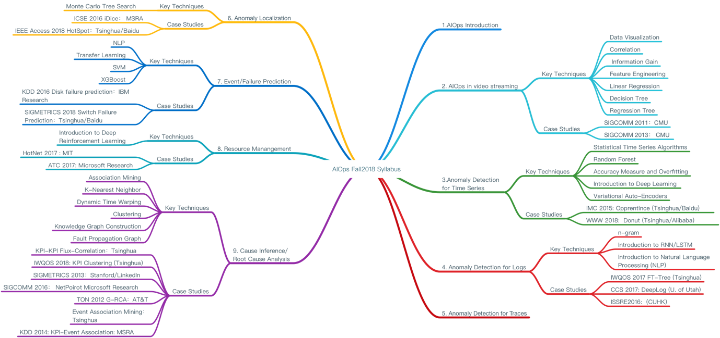
Week | Topic, Papers, Slides and Reading List | Algorithms & Techniques
1 | Course Introduction
2 | Video streaming | Data Visualization  Correlation, Regression, Information gain, Decision trees, Regression trees
3
4
5
6 | KPI Anomaly detection | Time series Algorithms.  Random Forests  Deep Generative Models (VAE & GAN)  Clustering  Similarity
7
8 | Log Anomaly Detection | Learning From Text  CNN  Deep Sequence Learning
9
10 | Anomaly Localization | Monte Carlo Tree Search
11 | Event/Failure Prediction | Regularization  SVM  Transfer Learning  Extreme Gradient Boosted Trees
12 | Resource Management | Deep Reinforcement Learning
13 | Operations Knowledge Graph | Association Mining  Causal Inference  Knowledge Graph
14
15
16 | Project Presentation

